FS4000,PTOBC288, and BC283
Brush cutter rotor comparisons
QUALITIES: | FIXED TOOTH | FLAIL CUTTER
MULCH | 90 % shards, ¾” dia. X 5” Long | 90% ¾” chips
SPEED | 85% of flail | Fastest
TOOTH LIFE | 300-400 hours (at best) | 100-200 hours (at best)
SHARPENING NEEDED | No | Yes, at about half of life
SURFACE ROCK | Yes | No
CUTS BELOW GROUND LEVEL | Yes | No
BELT LIFE | 75% of flail | Longest
BEARING LIFE | 75% of flail | Longest
SHAFT LIFE | 75% of flail | Longest
WEIGHT | Highest | Lowest

FIXED TOOTH PHOTOS:

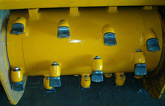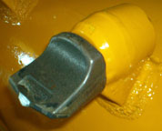

Rotor Head with Fixed Teeth Close-up on single tooth

FLAIL CUTTER PHOTOS:

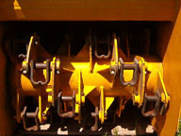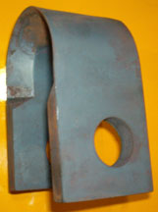

Rotor Head with Flail Cutters Close-up on single flail cutter

